Assignment 5 – Question 2
Part 1
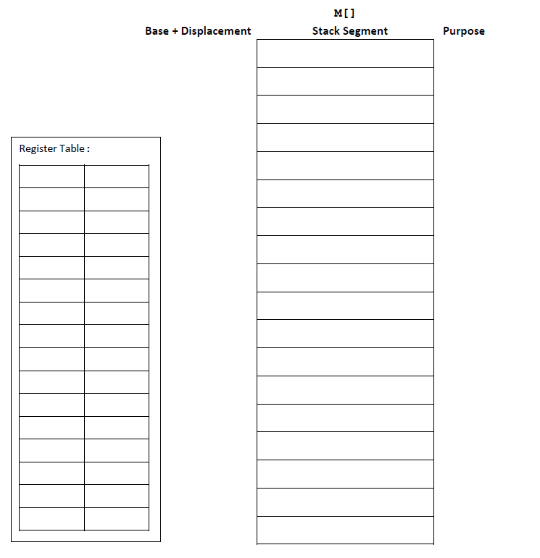
Part 2

What happens to the canary value when you reduce the size of buf from 40 down to 24, and x = 6, y = 9?

